NAME = MOHMADNIWAL GAVANDI

SR. NO. = 45

Create the project for any web application example using agile methodology (SCRUM

TEMPLATE).

(6 ISSUES); 4 STORY , 1 TASK, BUG

1) Create components

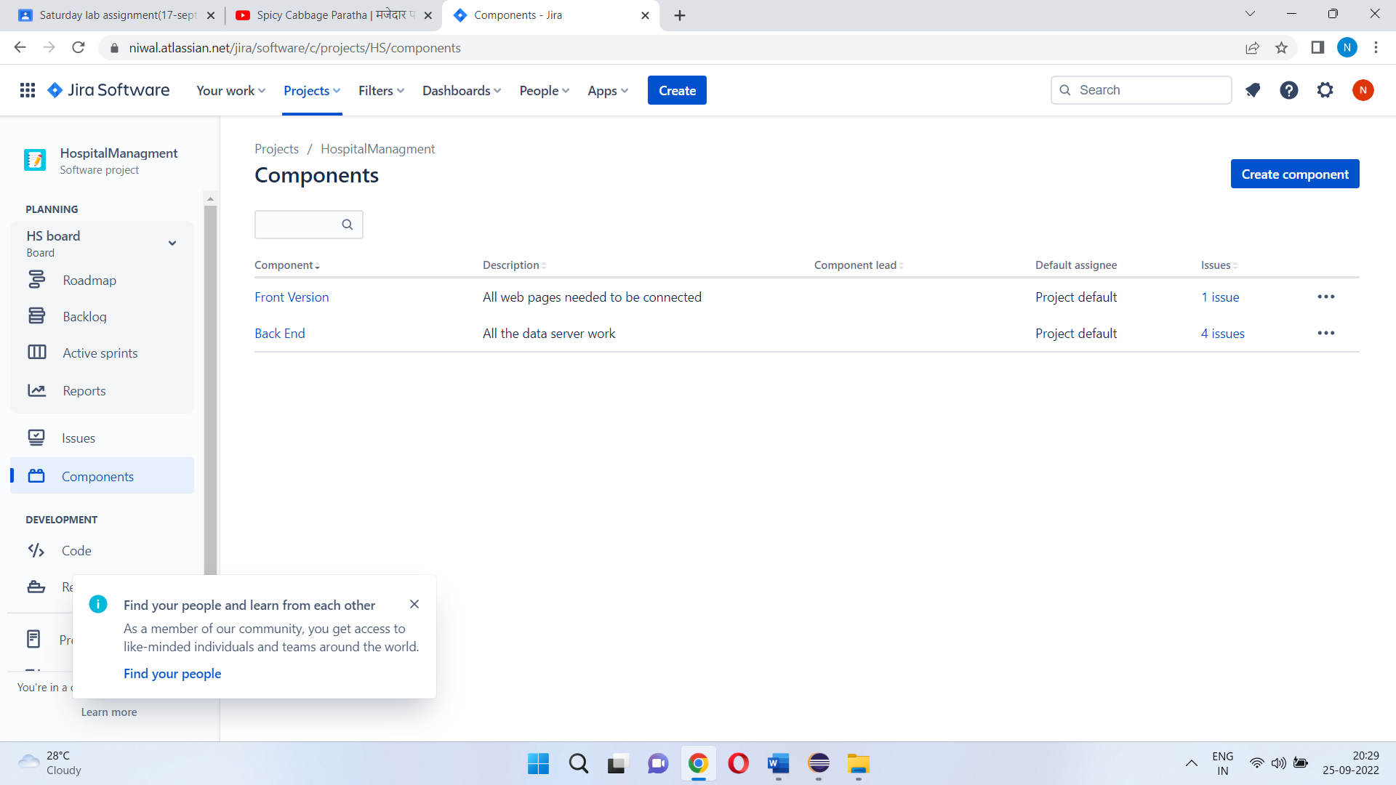

2) Plan the version with release dates

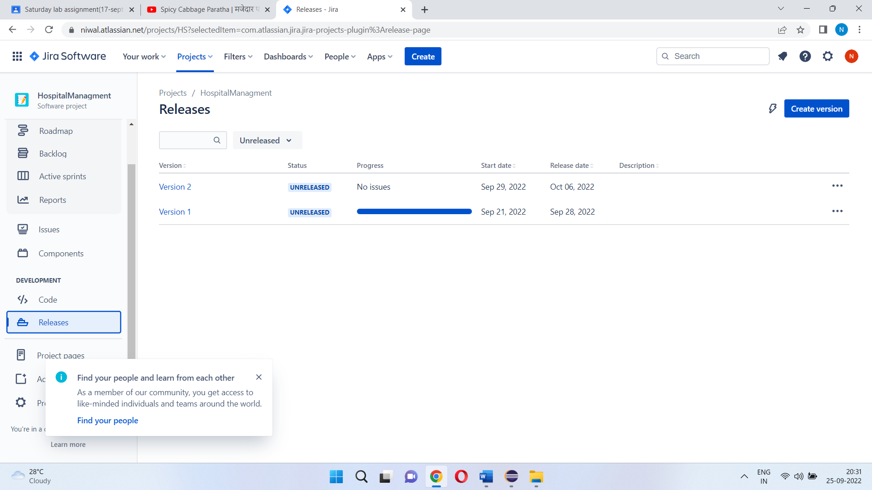

3) Create sprint backlog, start sprint and complete sprint

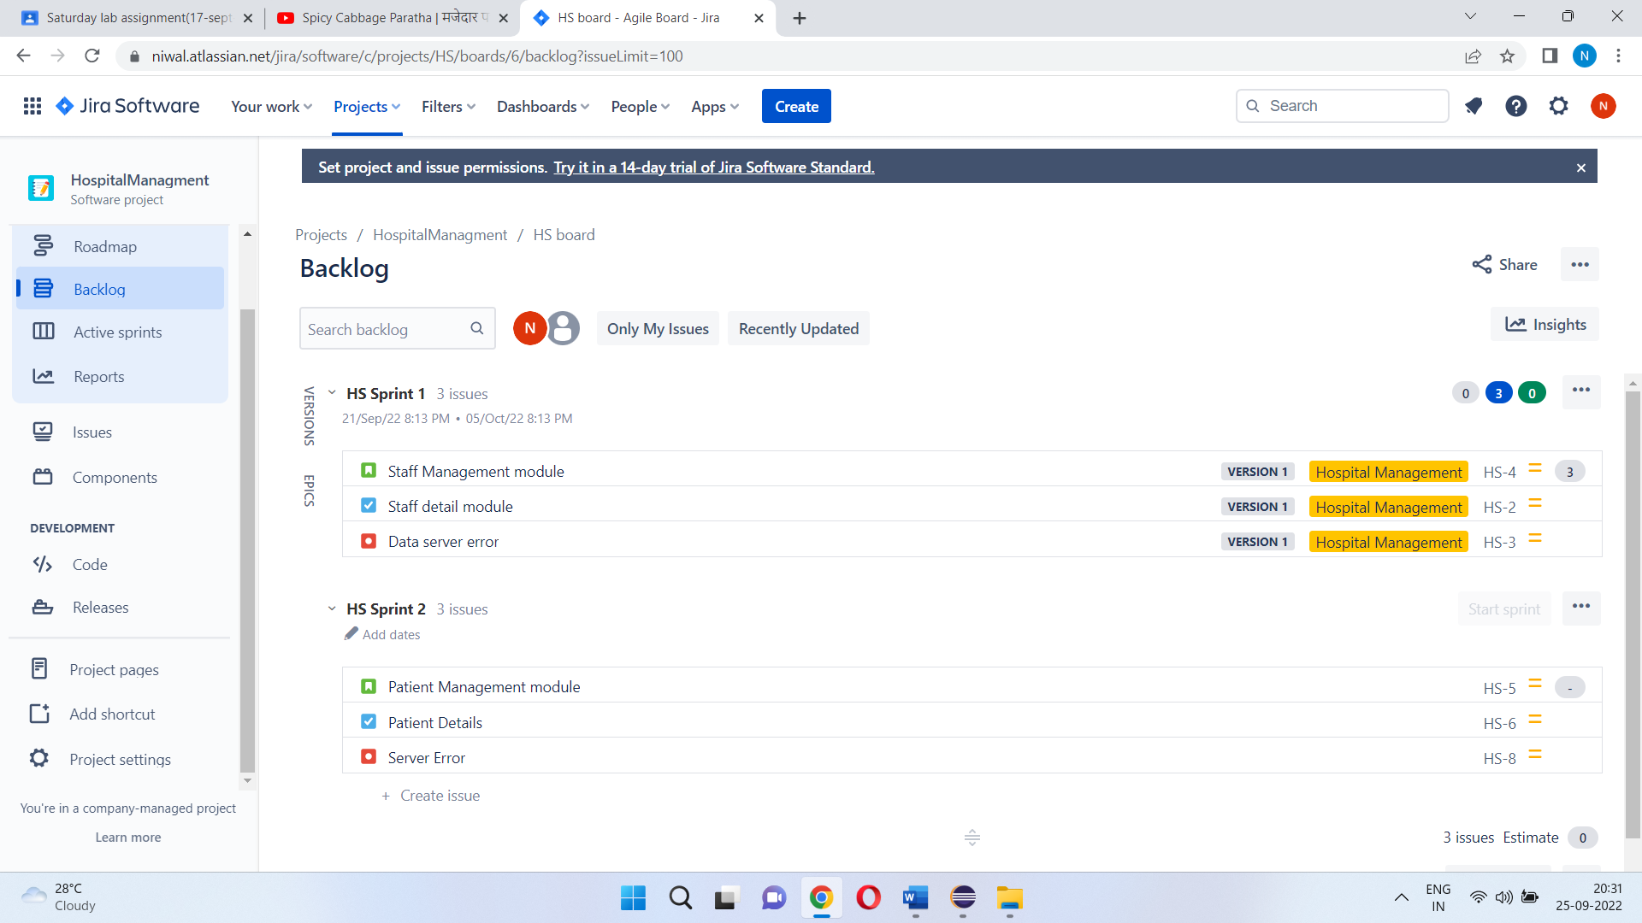

4) Create different types of issues in the backlog.

-Epic –provide epic link also

- Story

Initialize story point, Associate with Version, component ---

Divide into sub-tasks :::::Give estimate time

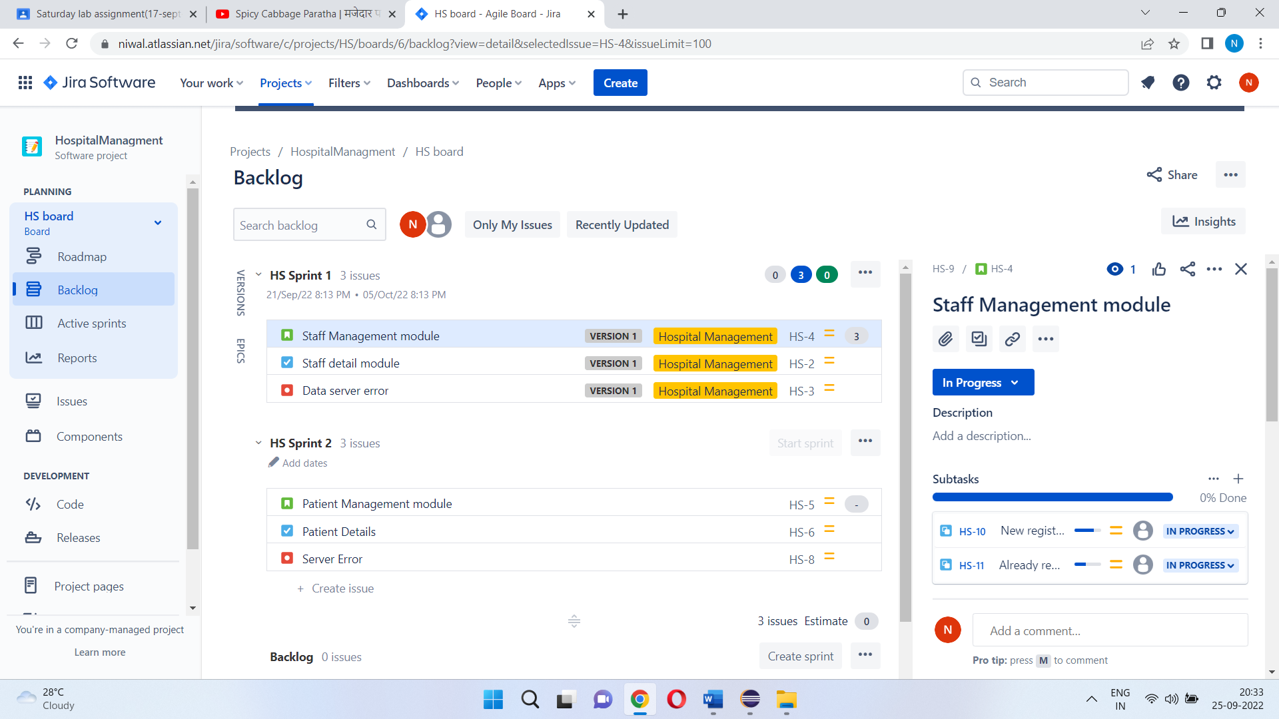

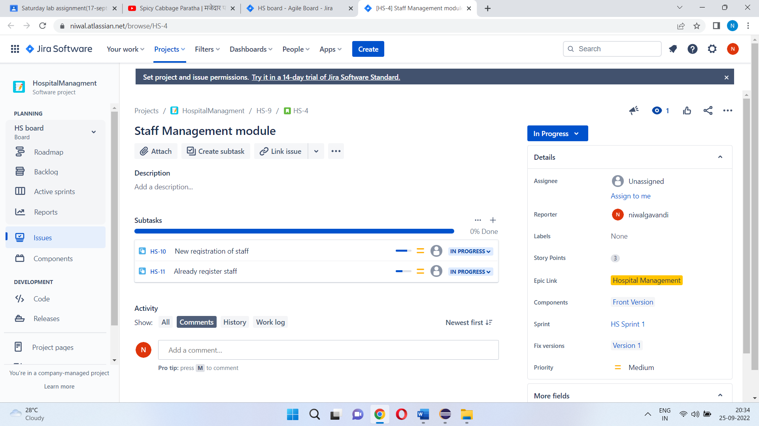

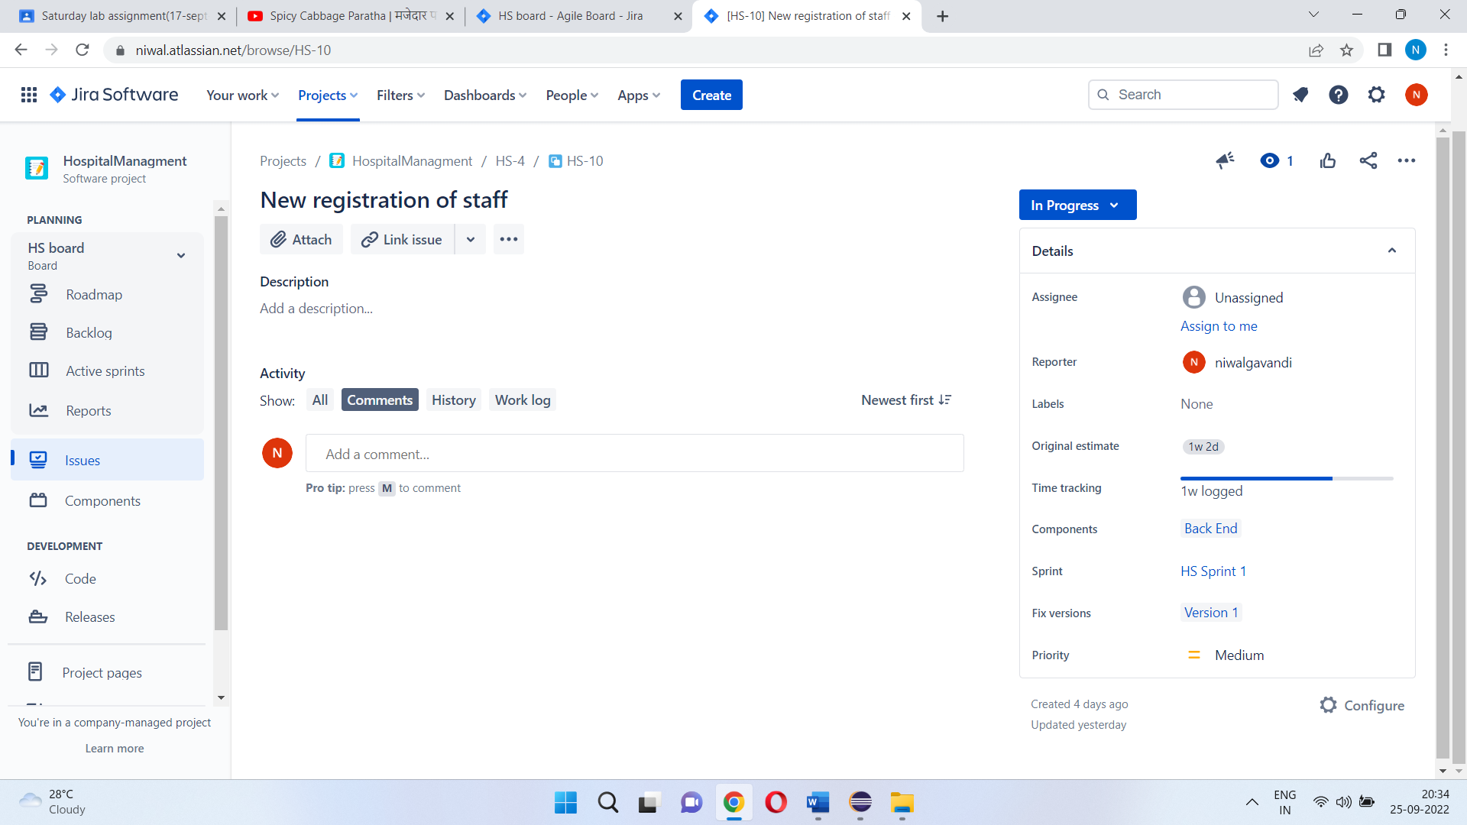

Give time log work and comment it as well. -Clone the story.

-task

-bug - Link with issues story

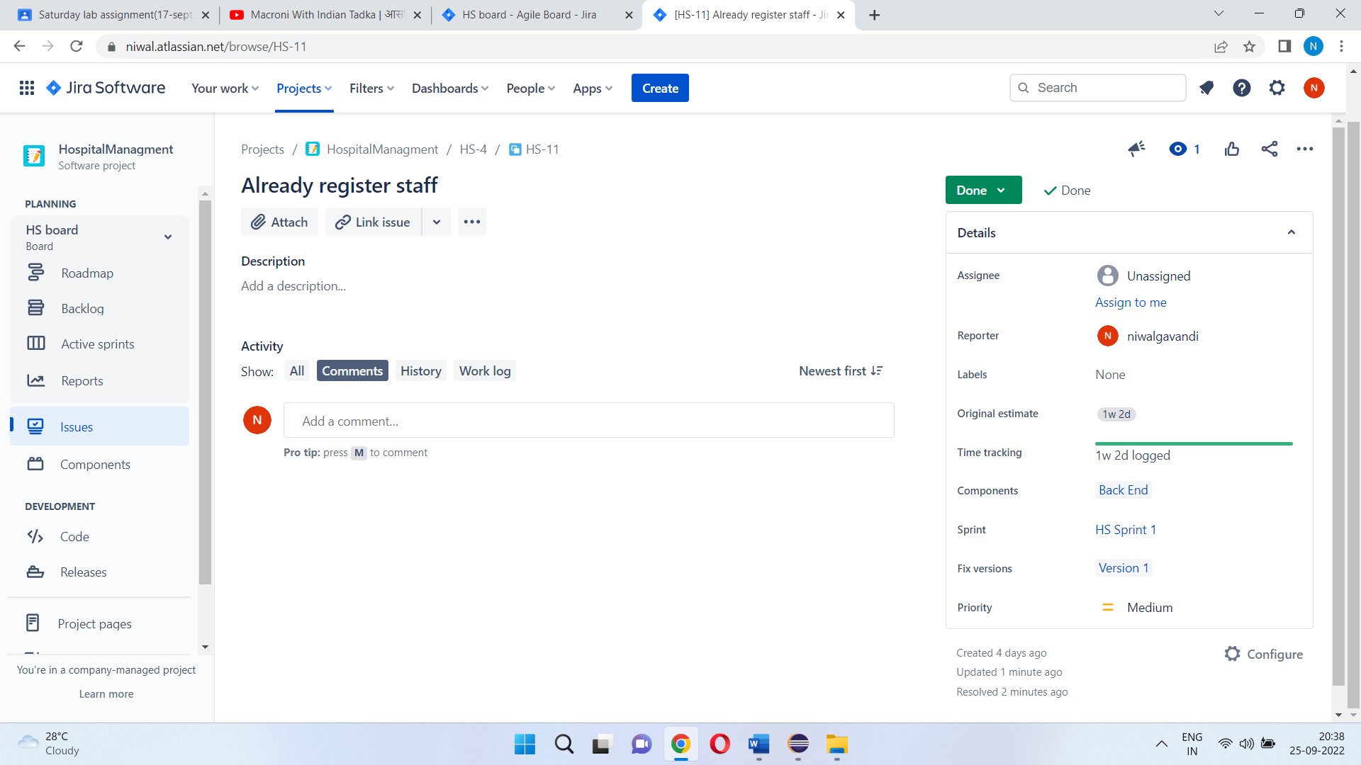

5) Evaluate burn down, burn up, analyse the sprint report and velocity charts.

